5. Data Access

Lab Contents
1 Overview 2
2 Introduction 2
3 Database Schema & Validation 3
4 Zod-Based Validation 4
4.1 Install dependencies 4
4.2 Define Zod validation schemas 4
5 Data Access Layer 7
6 Business Logic Layer (services) 10
7 UI & Server Actions Layers (+page.svelte & +page.server.js) 14
7.1 Loading data - +page.server.js (server actions layer) 14
7.2 Page component - +page.svelte (UI Layer) 14
8 Exercise - Add other pages 15

Overview
The purpose of this lab is to show the many layers of an application.

This lab will show you how to build a fully functional form workflow in SvelteKit with:
- Validation using Zod schemas generated from Drizzle ORM tables.
- Progressive form handling with SvelteKit form actions.
- Accessibility support that meets WCAG 2.1 AA standards.
- A structured, layered architecture for maintainable code.
- Unified validation and error reporting on both server and client.

Create a new folder, lab5.
Use your completed lab 4. Copy your files from lab4 into your lab5 folder.
Change the text from lab4 to lab5 in the package json files.

As a once off. If you did not finish lab 4 then you can use my solution. I am doing this so you will not fall behind and can do this lab. If you use my solution, then you will need to install the packages. Run npm install in the terminal to do this.

Complete the following tasks.

Introduction
Designing a web application for long-term maintainability and security requires clear separation of responsibilities between the client and server.

A layered architecture supports this by dividing responsibilities:

Layer | Responsibility
UI Layer | Pages, components, forms, and layouts
Server Actions | Form submission and request handling
Service Layer | Validation, authorization, and business rules
Data Access Layer (DAL) | Database operations through Drizzle ORM
Database Layer | Table definitions, constraints, and relations

This separation ensures each layer performs a single function, making the application more secure, maintainable, and testable.

UI Components → Server Actions → Services → Data Access → Database

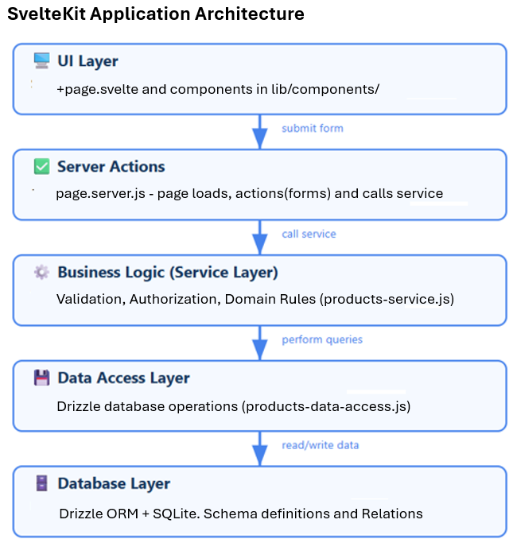

Recommended Folder Structure
This structure aligns with the separation of concerns principles used in enterprise applications.

📁 lab5
└── 📁 src
├── 📁 lib
│ ├── 📁 assets
│ ├── 📁 components
│ └── 📁 server
│ ├── 📁 data-access
│ ├── 📁 db
│ ├── 📁 services
│ ├── 📁 utils
│ └── index.js
├── 📁 routes
│ ├── 📁 products
│ │ ├── +page.server.js
│ │ └── +page.svelte
│ └── Other routes...

Database Schema & Validation
The database schema from the previous lab is reused here and for future labs.

M
M
1
Order
id (integer - auto)
userId (integer)
status (text)
total (integer)
createdAt (integer)
Order Details
id (integer - auto)
orderId (integer)
productId (integer)
quantity (integer)
unitPrice (integer)
Product
id (integer - auto)
name (text)
description (text)
price (integer)
image (text)
quantity (integer)
categoryId (integer)
Product Category
id (integer - auto)
name (text)
description (text)
User
id (integer - auto)
username (text)
passwordHash (text)
firstname (text)
surname (text)
dob (text)
email (text)
role (text)
1
M
1
M
1
Cart
id (integer - auto)
userId (integer)
createdAt (integer)
Cart Item
id (integer - auto)
cartId (integer)
productId (integer)
quantity (integer)
M
1
1
1
1
1
Session
id (text)
userId (integer)
productId (integer)
expiresAt (integer)
1
1

Zod-Based Validation
Zod provides a type-safe, declarative way to validate user input. Drizzle ORM integrates tightly with Zod, allowing schemas to be inferred directly from table definitions.

Install dependencies
npm install drizzle-zod zod

Define Zod validation schemas
In src/lib/server/db/validation.js, define validation rules for each model. Each field should include type requirements and customized error messages. Create this file and add the code just below.

Note - You will see that we first import the Zod schemas and our schema that we created in lab 4. We then create our own validation based on the Zod schemas.
In this example, we will concentrate on the Product and Product Categories tables. However, I have created validation for all tables. I have created CRUD validation (create/insert, read/select, update and delete).
Take time to review the code below. You will have to create your own validation later, so it is important to experiment yourself.
import { z } from 'zod';
import { createInsertSchema, createSelectSchema } from 'drizzle-zod';
import { user, productCategory, product, order, orderDetail } from './schema.js';

/** =========================
* User Schemas
* ========================= */
export const selectUserSchema = createSelectSchema(user);

export const insertUserSchema = createInsertSchema(user, {
username: z.string().min(2, 'Username must be at least 2 characters'),
passwordHash: z.string().min(6, 'Password is required'),
firstname: z.string().min(1, 'Firstname is required'),
surname: z.string().min(1, 'Surname is required'),
dob: z.string().min(1, 'Date of birth is required'),
email: z.string().email('Must be a valid email'),
role: z.enum(['user', 'admin']).default('user')
});

export const updateUserSchema = insertUserSchema
.partial()
.omit({
id: true,
passwordHash: true // update password separately
});

export const deleteUserSchema = z.object({
id: z.number().int().positive()
});

/** =========================
* Product Category Schemas
* ========================= */
export const selectCategorySchema = createSelectSchema(productCategory);

export const insertCategorySchema = createInsertSchema(productCategory, {
name: z.string().min(2, 'Category name is required'),
description: z.string().optional()
});

export const updateCategorySchema = insertCategorySchema
.partial()
.omit({ id: true });

export const deleteCategorySchema = z.object({
id: z.number().int().positive()
});

/** =========================
* Product Schemas
* ========================= */
export const selectProductSchema = createSelectSchema(product);

export const insertProductSchema = createInsertSchema(product, {
name: z.string().min(2, 'Product name is required'),
description: z.string().optional(),
price: z.number().int().min(1, 'Price must be at least 1 cent'),
image: z.string().optional(),
quantity: z.number().int().min(0, 'Quantity cannot be negative'),
categoryId: z.number().int().min(1, 'Category ID is required')
});

export const updateProductSchema = insertProductSchema
.partial()
.omit({ id: true });

export const deleteProductSchema = z.object({
id: z.number().int().positive()
});

/** =========================
* Order Schemas
* ========================= */
export const selectOrderSchema = createSelectSchema(order);

export const insertOrderSchema = createInsertSchema(order, {
userId: z.number().int().min(1, 'User ID is required'),
status: z.string().default('pending'),
total: z.number().int().min(0, 'Total cannot be negative')
});

export const updateOrderSchema = insertOrderSchema
.partial()
.omit({
id: true,
userId: true
});

export const deleteOrderSchema = z.object({
id: z.number().int().positive()
});

/** =========================
* Order Detail Schemas
* ========================= */
export const selectOrderDetailSchema = createSelectSchema(orderDetail);

export const insertOrderDetailSchema = createInsertSchema(orderDetail, {
orderId: z.number().int().min(1, 'Order ID is required'),
productId: z.number().int().min(1, 'Product ID is required'),
quantity: z.number().int().min(1, 'Quantity must be at least 1'),
unitPrice: z.number().int().min(1, 'Unit price is required')
});

export const updateOrderDetailSchema = insertOrderDetailSchema
.partial()
.omit({
id: true,
orderId: true,
productId: true
});

export const deleteOrderDetailSchema = z.object({
id: z.number().int().positive()
});

Benefits of Schema-Based Validation
- Single source of truth: The schema defines both validation and typing.
- Type safety: Prevents runtime type errors.
- Reduced redundancy: Eliminates duplicate validation logic.
- Better tooling: IDE autocompletion and static analysis.

Data Access Layer
The Data Access Layer centralizes all database operations, providing a clean interface for queries and updates. Keep your DAL functions pure — they should only handle data interactions, not business logic. We will create a DAL for product and product categories.

Why Use a DAL?
- Prevents code duplication across pages or services.
- Makes database changes easier (e.g., replacing SQLite with PostgreSQL).
- Improves maintainability and security.

1. Create the folder and file - src/lib/server/data-access/products-data-access.js
In this file you can see the SQL like code to perform CRUD and find queries on the database. You need to take a moment to familiarize yourself with this new code. You will have to do the same later for the other tables.

I have added console logs that you look for when you run your application later.
import { db } from '../db/index.js';
import { product } from '../db/schema.js';
import { eq } from 'drizzle-orm';

export const productsDataAccess = {

/** Find a product by its ID */
async findById(id) {
const result = await db.select().from(product).where(eq(product.id, id)).limit(1);
return result[0] ?? null;
},

/** Find a product by its name */
async findByName(name) {
const result = await db.select().from(product).where(eq(product.name, name)).limit(1);
return result[0] ?? null;
},

/** Get all products */
async findAll() {
return await db.select().from(product);
},

/** Get products by category */
async findByCategory(categoryId) {
return await db.select().from(product).where(eq(product.categoryId, categoryId));
},

/** Create a new product */
async create(productData) {
const result = await db.insert(product).values(productData).returning();
console.log("Added product >>>>>>>", result[0]);
return result[0];
},

/** Update an existing product */
async update(id, productData) {
const result = await db.update(product).set(productData).where(eq(product.id, id)).returning();
console.log("Updated product >>>>>>>", result[0]);
return result[0];
},

/** Delete a product */
async delete(id) {
const result = await db.delete(product).where(eq(product.id, id));
console.log("Deleted product >>>>>>>", result);
return result.rowsAffected > 0;
}
};

2. Create the file - src/lib/server/data-access/categories-data-access.js
import { db } from '../db/index.js';
import { productCategory } from '../db/schema.js';
import { eq } from 'drizzle-orm';

export const categoriesDataAccess = {

/** Find a category by its ID */
async findById(id) {
const result = await db.select().from(productCategory).where(eq(productCategory.id, id)).limit(1);
return result[0] ?? null;
},

/** Find a category by its name */
async findByName(name) {
const result = await db.select().from(productCategory).where(eq(productCategory.name, name)).limit(1);
return result[0] ?? null;
},

/** Get all categories */
async findAll() {
return await db.select().from(productCategory);
},

/** Create a new category */
async create(categoryData) {
const result = await db.insert(productCategory).values(categoryData).returning();
console.log("Added category >>>>>>>", result[0]);
return result[0];
},

/** Update an existing category */
async update(id, categoryData) {
const result = await db.update(productCategory).set(categoryData).where(eq(productCategory.id, id)).returning();
console.log("Updated category >>>>>>>", result[0]);
return result[0];
},

/** Delete a category */
async delete(id) {
const result = await db.delete(productCategory).where(eq(productCategory.id, id));
console.log("Deleted category >>>>>>>", result);
return result.rowsAffected > 0;
}
};

Business Logic Layer (services)
The Service Layer performs validation, permission checks, and applies domain rules before database operations occur. This layer uses both Zod validators and DAL functions. Again, we will two files for product and product categories.

1. Create the folder and file - src/lib/server/services/products-service.js
There is a lot of code below. You will see how functions in this class call functions in the Zod schema validation class and the data access class we just created.

Review the SvelteKit architecture diagram in the introduction section above to remind yourself of the different layers and how they are connected.

Review the individual functions exported from productsService below.
// productsService.js
import { productsDataAccess } from '../data-access/products-data-access.js';
import { ValidationError, NotFoundError } from '../utils/errors.js';
import { insertProductSchema, updateProductSchema, deleteProductSchema } from '../db/validation.js';

// The Service Layer performs validation, permission checks,
// and applies domain rules before database operations occur.
// This layer uses both Zod validators and DAL functions.
export const productsService = {

/** Get a product by ID */
async getProductById(id) {
const product = await productsDataAccess.findById(id);
if (!product) throw new NotFoundError('Product not found');
return product;
},

/** Get a product by name */
async getProductByName(name) {
const product = await productsDataAccess.findByName(name);
if (!product) throw new NotFoundError('Product not found');
return product;
},

/** Get all products */
async getAllProducts() {
return await productsDataAccess.findAll();
},

/** Get all products in a category */
async getProductsByCategory(categoryId) {
return await productsDataAccess.findByCategory(categoryId);
},

/** Create a new product */
async createProduct(productData) {
console.log("IN createProduct >>>>>>");
// Validate with Zod
const validated = insertProductSchema.parse(productData);
return await productsDataAccess.create(validated);
},

/** Update a product */
async updateProduct(id, productData) {
console.log("IN updateProduct >>>>>>");
// Validate with Zod
const validated = updateProductSchema.parse(productData);

const updatedProduct = await productsDataAccess.update(id, validated);
if (!updatedProduct) throw new NotFoundError('Product not found after update');

return updatedProduct;
},

/** Delete a product */
async deleteProduct(id) {
console.log("IN deleteProduct >>>>>>");
// Validate with Zod (expects object with id)
const validated = deleteProductSchema.parse({ id });

const deleted = await productsDataAccess.delete(validated.id);
if (!deleted) throw new NotFoundError('Product not found to delete');

return deleted;
}
};

2. Create the file - src/lib/server/services/categories-service.js
import { categoriesDataAccess } from '../data-access/categories-data-access.js';
import { NotFoundError } from '../utils/errors.js';
import { insertCategorySchema, updateCategorySchema, deleteCategorySchema } from '../db/validation.js';

// The Service Layer performs validation, permission checks,
// and applies domain rules before database operations occur.
export const categoriesService = {

/** Get category by ID */
async getCategoryById(id) {
const category = await categoriesDataAccess.findById(id);
if (!category) throw new NotFoundError('Category not found');
return category;
},

/** Get category by name */
async getCategoryByName(name) {
const category = await categoriesDataAccess.findByName(name);
if (!category) throw new NotFoundError('Category not found');
return category;
},

/** Get all categories */
async getAllCategories() {
return await categoriesDataAccess.findAll();
},

/** Create a new category */
async createCategory(categoryData) {
console.log('IN createCategory >>>>>>');
const validated = insertCategorySchema.parse(categoryData);
return await categoriesDataAccess.create(validated);
},

/** Update a category */
async updateCategory(id, categoryData) {
console.log('IN updateCategory >>>>>>');
const validated = updateCategorySchema.parse(categoryData);

const updatedCategory = await categoriesDataAccess.update(id, validated);
if (!updatedCategory) throw new NotFoundError('Category not found after update');

return updatedCategory;
},

/** Delete a category */
async deleteCategory(id) {
console.log('IN deleteCategory >>>>>>', id);
const validated = deleteCategorySchema.parse({ id });

const deleted = await categoriesDataAccess.delete(validated.id);
if (!deleted) throw new NotFoundError('Category not found to delete');

return deleted;
}
};

We have imported an errors.js class in the code above. We have created this errors class to customize our error handling with Zod. Create this class now.

3. Create the folder and file - src/lib/server/utils/errors.js
import { ZodError } from 'zod';

export class ValidationError extends Error {
constructor(message) {
super(message);
this.name = 'ValidationError';
}
}

export class NotFoundError extends Error {
constructor(message) {
super(message);
this.name = 'NotFoundError';
}
}

export class ForbiddenError extends Error {
constructor(message) {
super(message);
this.name = 'ForbiddenError';
}
}

export function handleError(error) {
if (error instanceof ZodError) {
return {
status: 400,
message: error.issues.map(e => `${e.path.join('.')}: ${e.message}`).join(', ')
};
}

if (error instanceof ValidationError) {
return { status: 400, message: error.message };
}

if (error instanceof NotFoundError) {
return { status: 404, message: error.message };
}

if (error instanceof ForbiddenError) {
return { status: 403, message: error.message };
}

return { status: 500, message: 'Internal server error' };
}

UI & Server Actions Layers (+page.svelte & +page.server.js)
The UI Layer renders data, handles user input, and manages state. The server action layer provides the data. This lab focuses on the products route.

In lab 4, we wrote code for these two files. We now need to update our code to reflect the different layers we have just created.

Loading data - +page.server.js (server actions layer)
Rather than directly accessing the database, we load data by calling service-layer functions. Modify your code with below.
- Import the new files we just created.
- Call the service rather than the database directly
- Return the data as before

import { productsService } from '$lib/server/services/products-service.js';
import { categoriesService } from '$lib/server/services/categories-service.js';
import { error, fail } from '@sveltejs/kit';
import { ZodError } from 'zod';

// load - server side
export async function load() {

try {
const prods = await productsService.getAllProducts();
const prodCats = await categoriesService.getAllCategories();

// return data
return {
products: prods,
categories: prodCats
}
} catch (err) {
console.error('Error retrieving products:', err);
return fail(500, { err });
}
}

Page component - +page.svelte (UI Layer)
No changes are required to keep your page working as it did before. You should see all the products displayed.
Test, check the VSC code terminal and browser console logs to ensure everything works and you get no errors. Below is my app running.

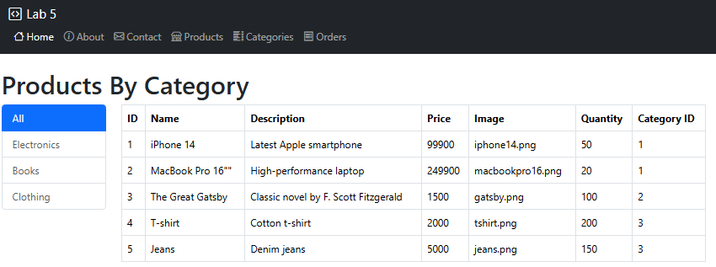

Exercise - Add other pages
We have now gone end to end for products and categories. That is, the page loads and we make calls through the new layers to get data from the database and display the data back on the page/UI. There is a lot going on here, so you need to go through this several times to understand what is happening. Therefore, a good test for you is to do what we have done for other pages.

Create the page/route and all the layers needed to retrieve data from the database for:
- Orders
- Categories
- Users

If you want a challenge this week, display the order details when the user click on an order.

Note - There is one significant difference between the implementation of orders and products and that is how an order is created. Review the database schema to see this.

An order will be made up of order details. So, when a user creates an order, there will be a row created in the order table and then row(s) created in the order detail table for every different product they ordered.

Therefore, when we retrieve a complete order, we must retrieve the order row in the orders tables and all the matching rows in the order detail table. I want to highlight the code to achieve this.

Service Layer – orders-service.js
/** Create a new order */
async createOrder(orderData, items) {

if (!items?.length) throw new ValidationError('Order must have at least one item');

// dynamically create the total for the order
const total = items.reduce((sum, i) => sum + (i.quantity * i.unitPrice), 0);

const validatedOrder = insertOrderSchema.parse({...orderData, total});

return await ordersDataAccess.create(validatedOrder, items);
},

DAL Layer – orders.js
/** Create a new order (with details) */
async create(orderData, items) {
return await db.transaction(async (tx) => {
const orderResult = await tx.insert(order).values(orderData).returning();
const newOrder = orderResult[0];

if (items?.length)
await tx.insert(orderDetail).values(items.map(i => ({ ...i, orderId: newOrder.id })));

return newOrder;
});
},

